**API End Points and Communication**

**Day 13: 21 March 28**

**Rest API URL on**

**Employee/Customer/Login/Account/ etc**

1. **Retrieve all Employee details:** we can use get method to retrieve all employee details.
2. **Retrieve employee details base upon some property ie Id,name,age,salary etc.**

Id we need to pass using path param

1. Store employee details : we need to use post methods.
2. Delete employee details. We need to use delete methods
3. Update employee details we need to use put method or patch methods

Creating Employee Rest API end points

Starter -🡪 Web Starter

starter -🡪 JPA starter

dependency 🡪 MySQL

starter 🡪 devtools : this starter help use to re-run the application whenever we do any changes.

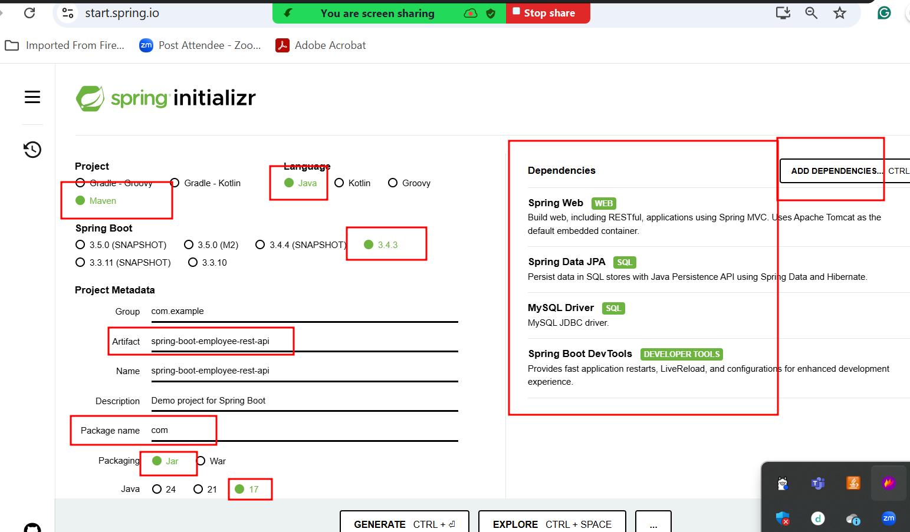

Post main client plugin is a one the open source rest api testing plugin which help to test rest api end points.

Post method testing through post man client

